THE UNIVERSITY OF AZAD JAMMU & KASHMIR

Student Name: Qurat Ul Ain Fatima
Roll No: 2024-SE-05
Course Title: Database Systems
Course Code: CS-2204
Lab Instructor: Awais Rathore
Department: Software Engineering
OPEN ENDED LAB
1:Database Creation:
The CarGoRentals database is created using the CREATE DATABASE command.
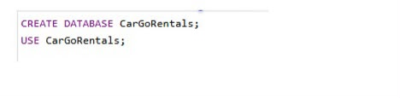
2:Customer Table:
The customer table is created with a primary key, unique phone number, and unique email constraint.
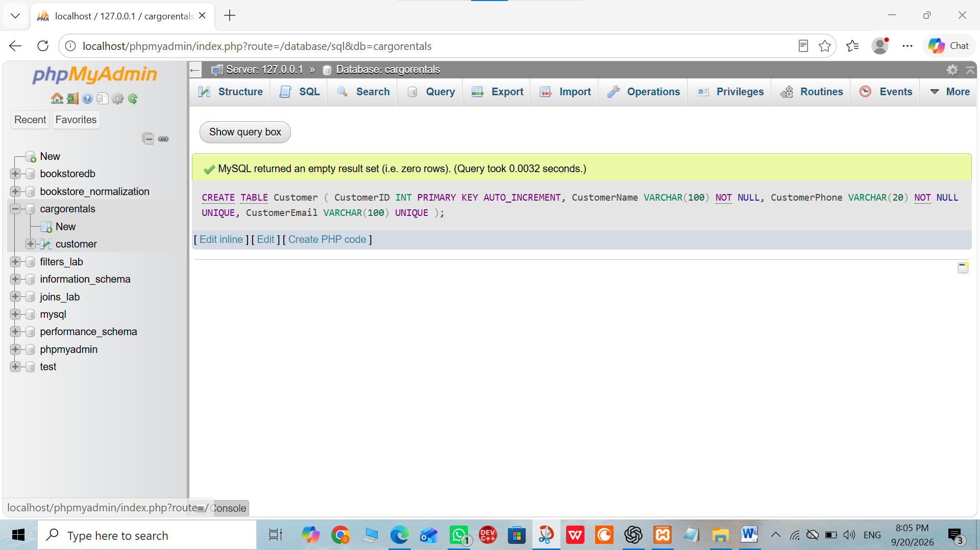
3:Vehicle Table:
The vehicle table is created with a primary key, unique vehicle number ,daily rate, status, along with appropriate CHECK constraints.
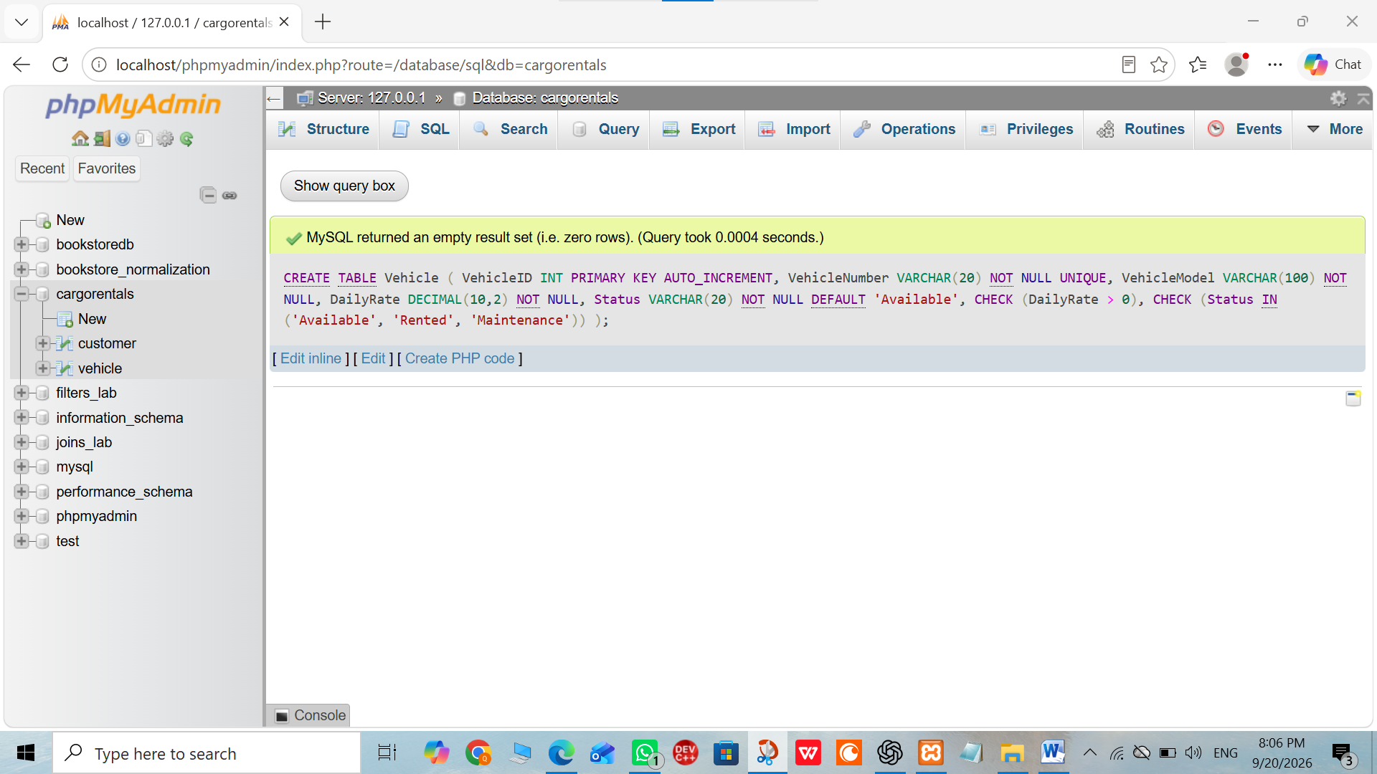
4:Rental Table:
The rental table is created with primary and foreign keys along with appropriate CHECK constraints.
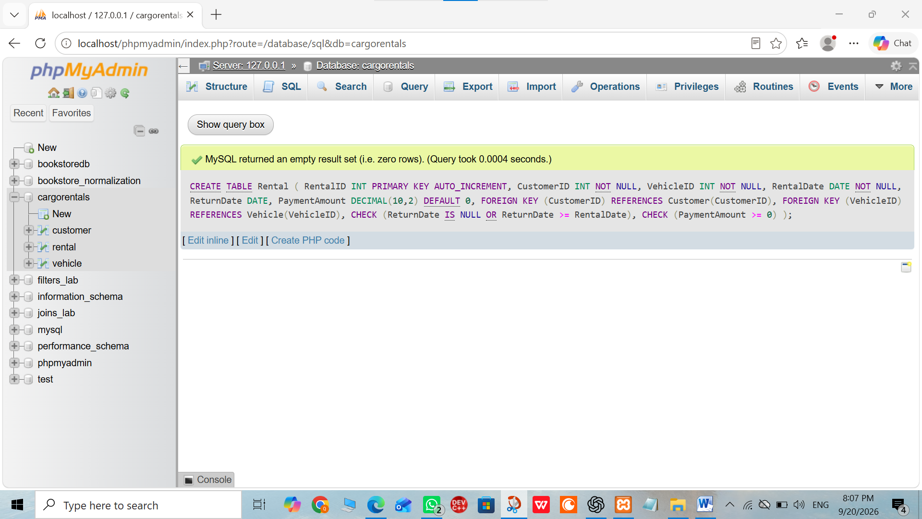

5: Payment Table:
The Payment table is created to store payment information related to vehicle rentals.
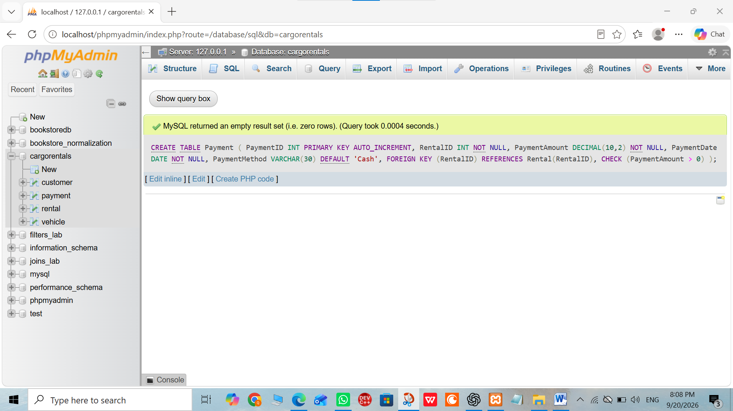
6: Customer Data:
Insertion of Customer Records
Sample customer records are inserted into the Customer table.
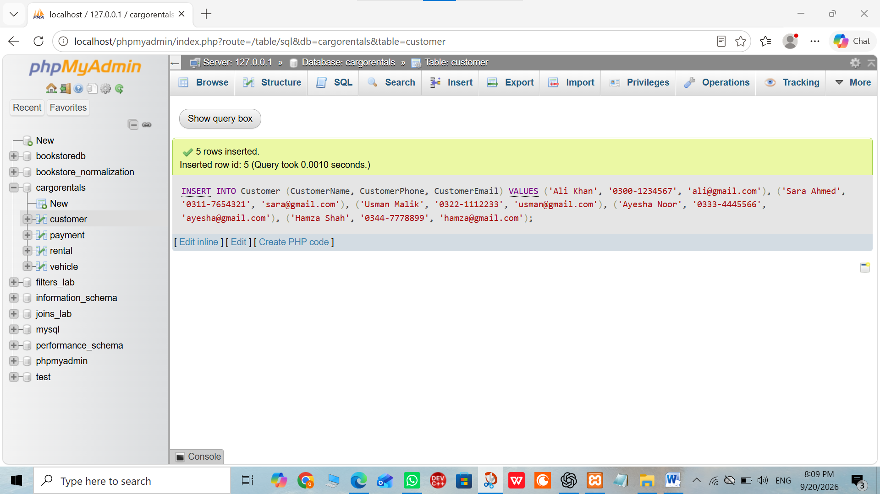
7: Vehicle Data:
Insertion of Vehicle Records
Sample vehicle records are inserted into the Vehicle table.
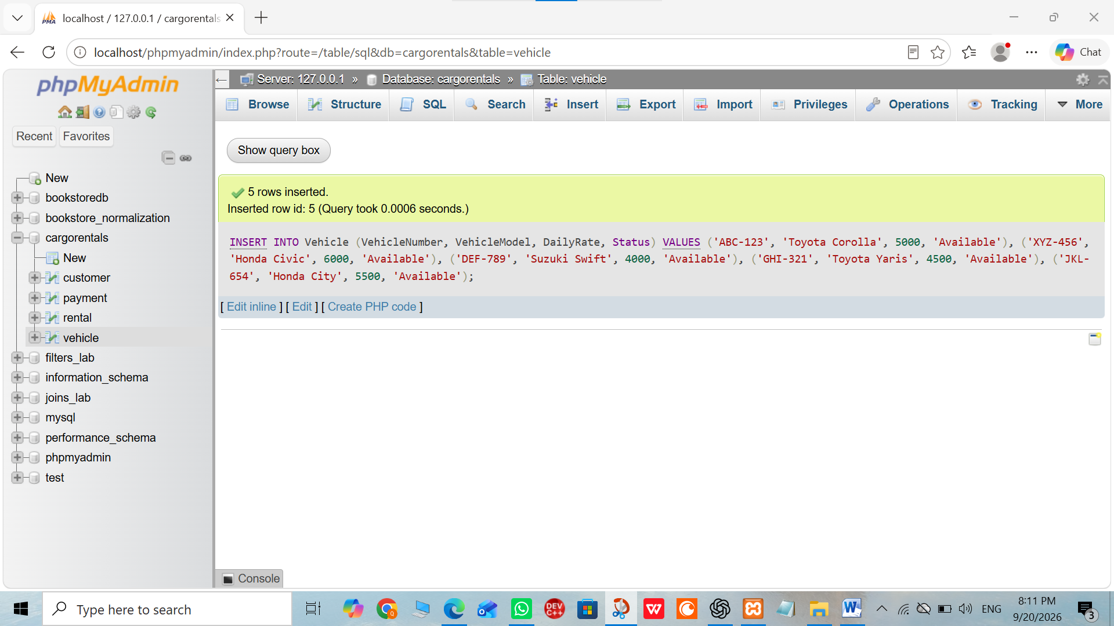
8: Rental Data:
Insertion of Rental Records
Sample rental records are inserted into the Rental table, including completed and ongoing rentals.
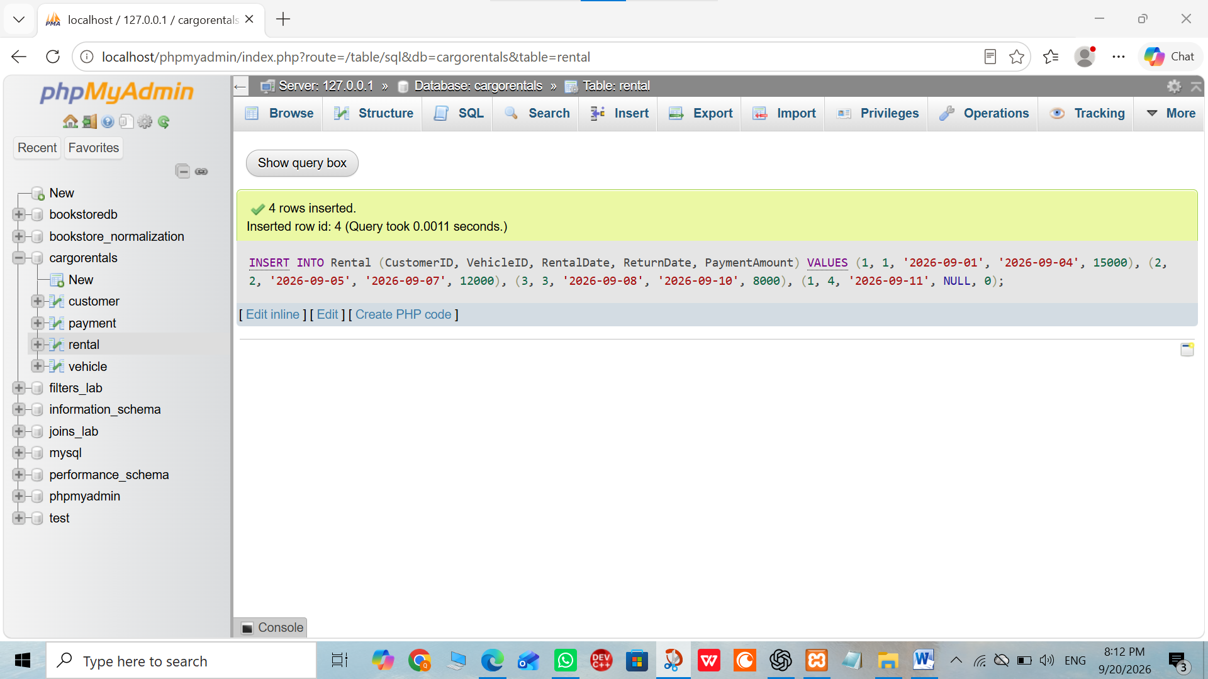
9: Payment Data:
Insertion of Payment Records
Sample payment records are inserted into the Payment table.
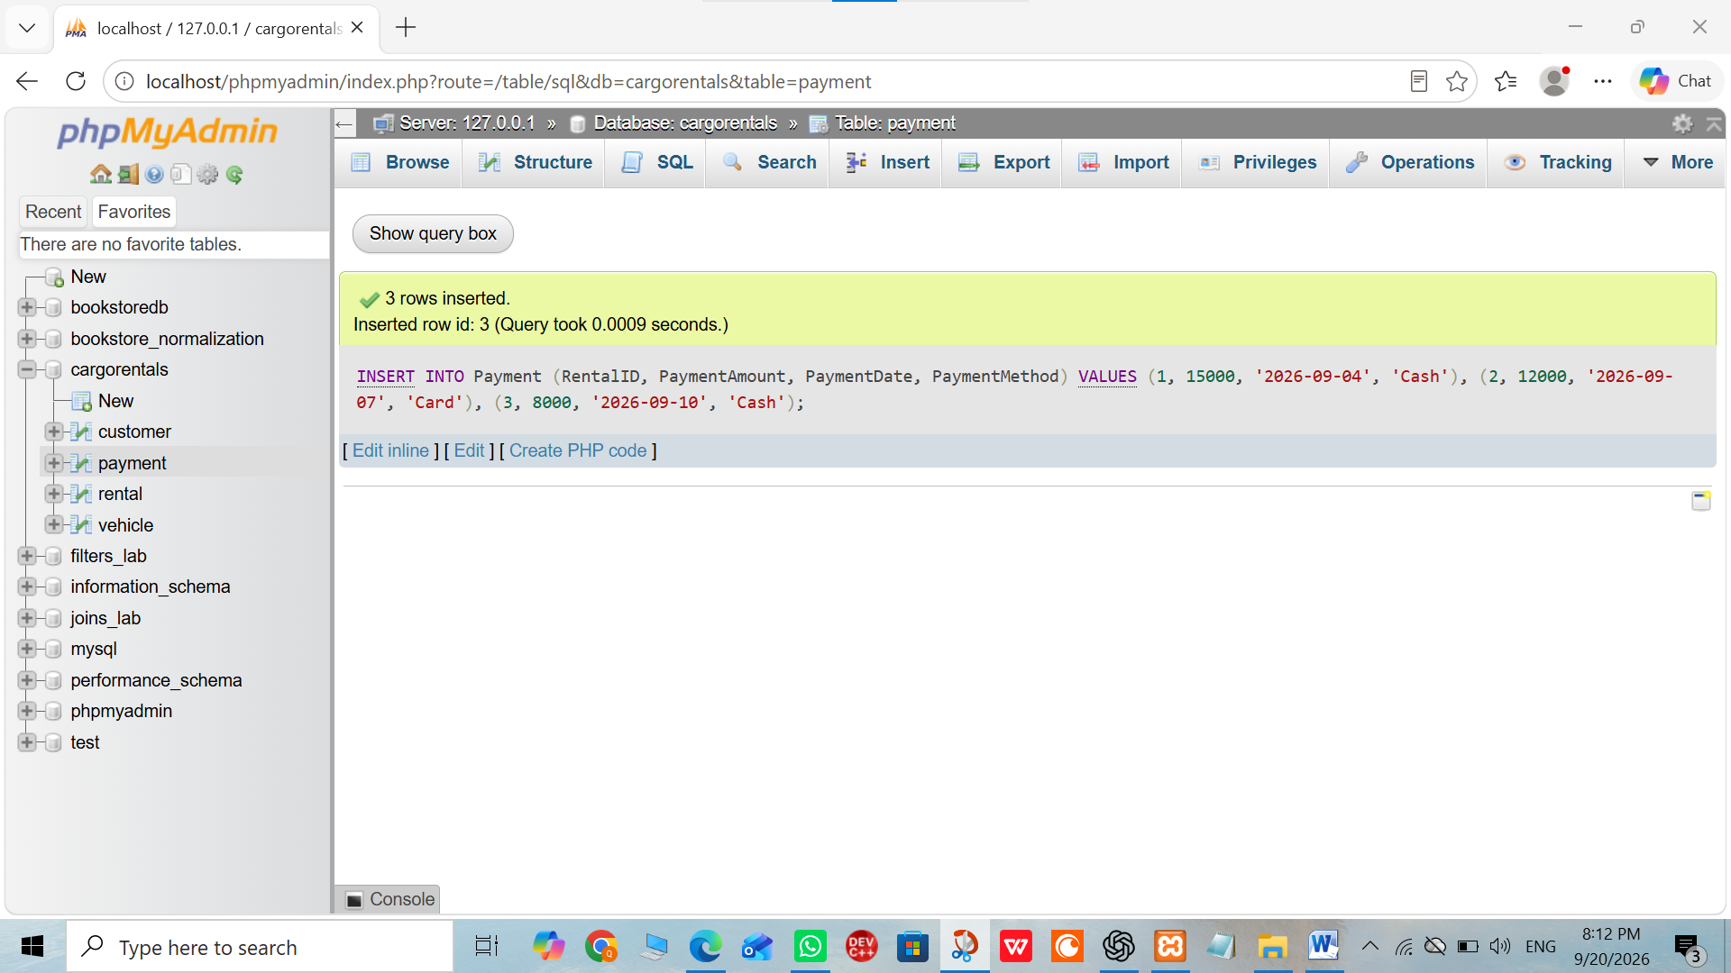

JOIN / Query Section:
10: INNER JOIN:
INNER JOIN Query
An INNER JOIN is used to display customer, vehicle, and rental information for matching records.
11: LEFT JOIN:
LEFT JOIN Query
A LEFT JOIN is used to display all customers along with their rental and vehicle information, including customers who have no rental.
12 : Vehicle and Rental LEFT JOIN:
LEFT JOIN for Vehicles and Rentals
A LEFT JOIN is used to display all vehicles and their rental information, including vehicles that have not been rented.
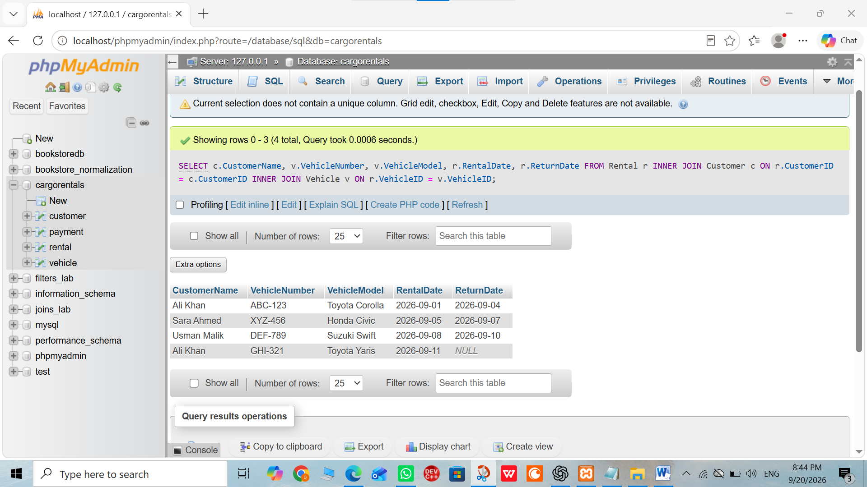
13: GROUP BY and Aggregate Function:
GROUP BY and Aggregate Query
The COUNT() function with GROUP BY is used to calculate the total number of rentals made by each customer.
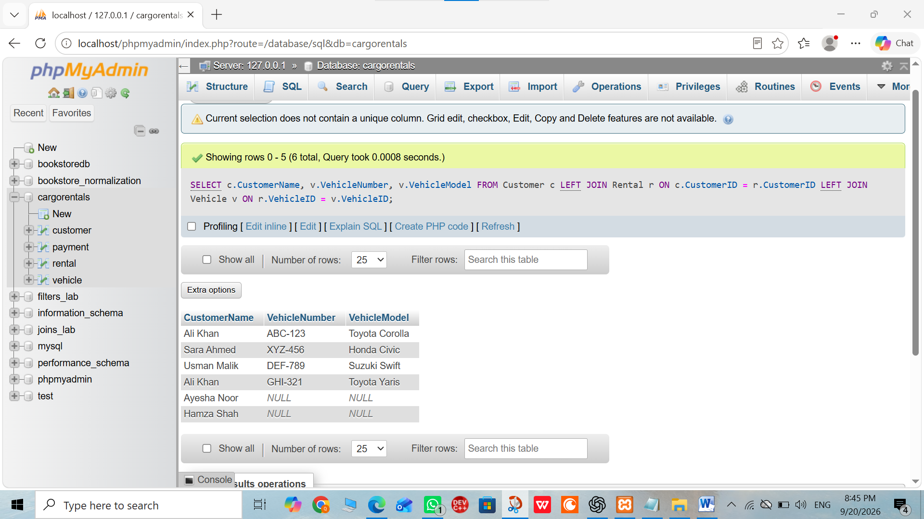
14: Creating a View:
Creation of Rental Report View
A database view is created to provide a reusable rental report based on the required rental information.
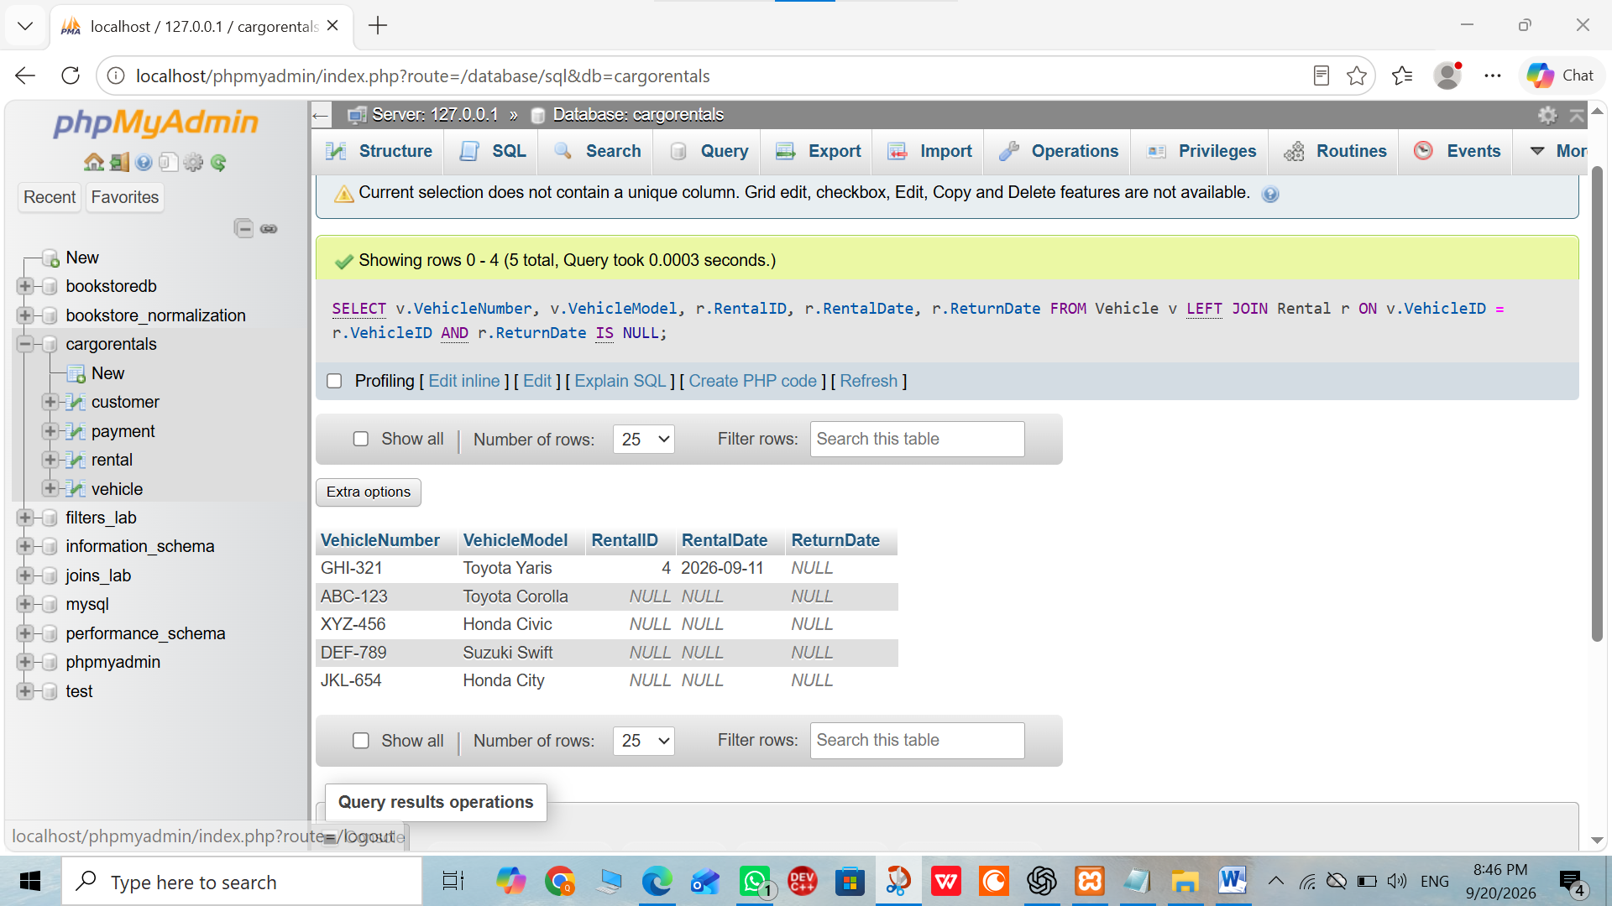
15: Trigger:
Creation of Trigger
An AFTER INSERT trigger is created on the Rental table to automatically update the vehicle status to Rented when a new rental is inserted.
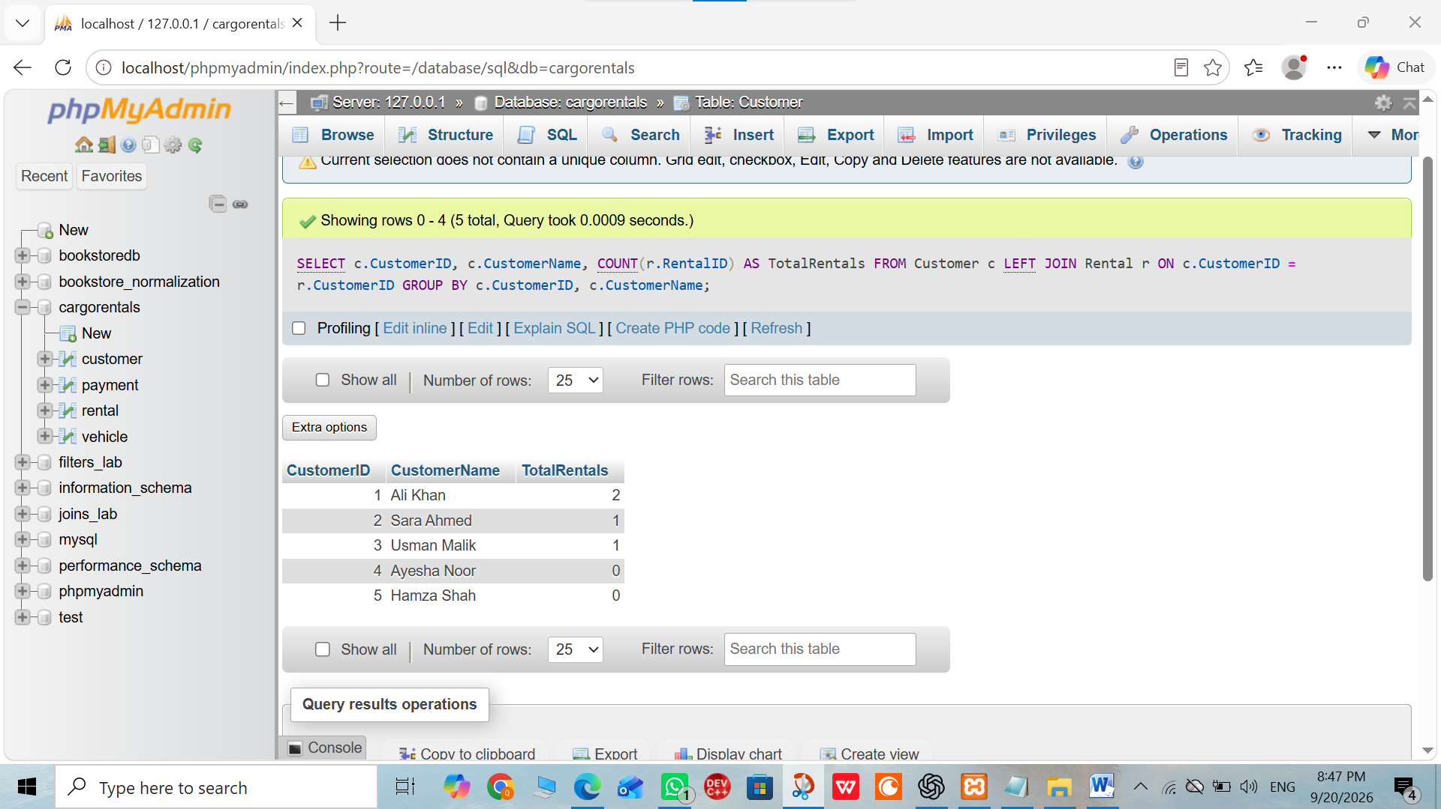

Stored Procedure:
16 :Stored Procedure:
Creation of Stored Procedure
The RegisterRental stored procedure is created to register a rental, calculate the rental amount according to the number of days and daily rate, and insert the rental record.
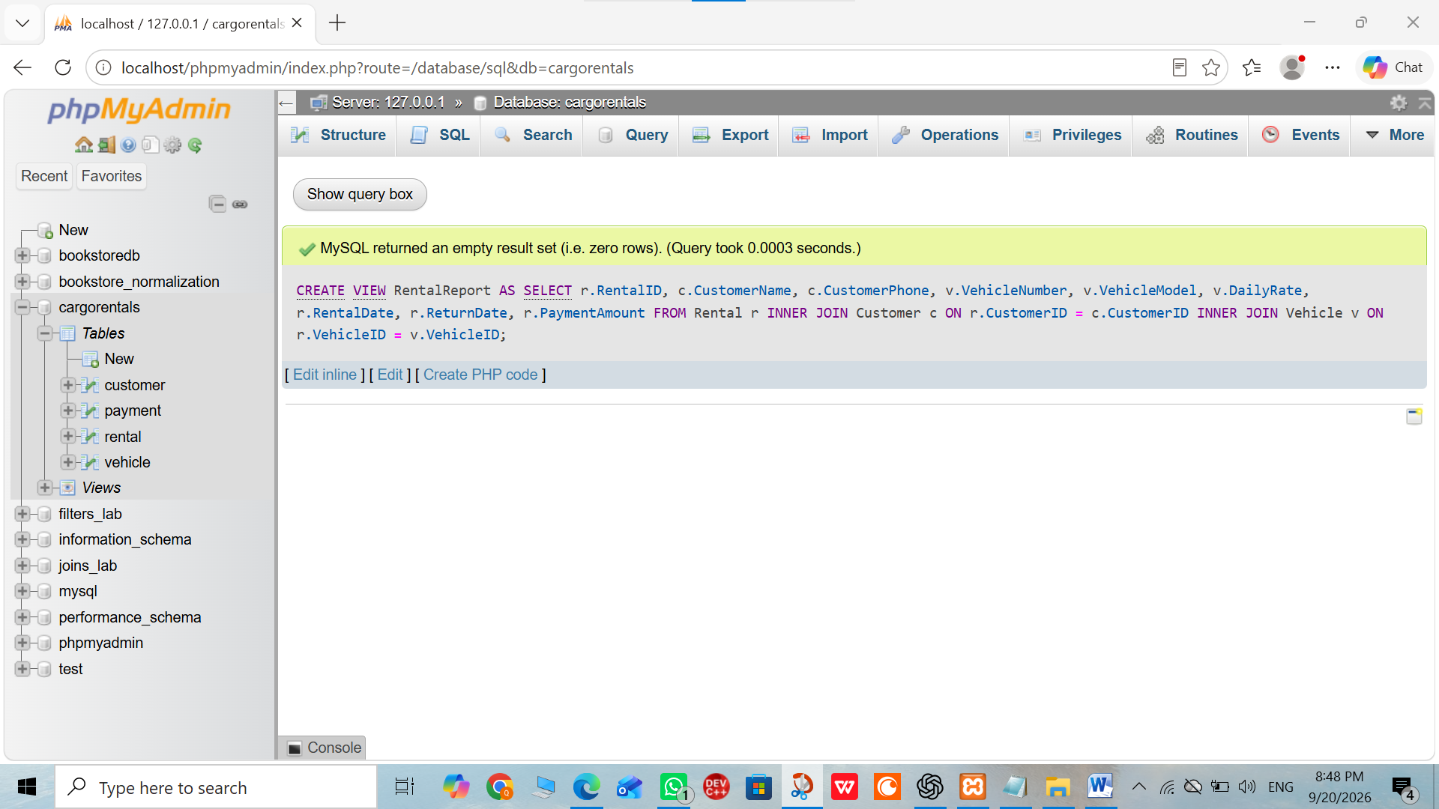

Indexing / Optimization:

17: Customer Index:
Creating Index on CustomerID
An index named idx_rental_customer is created on the CustomerID column of the Rental table to improve query performance.
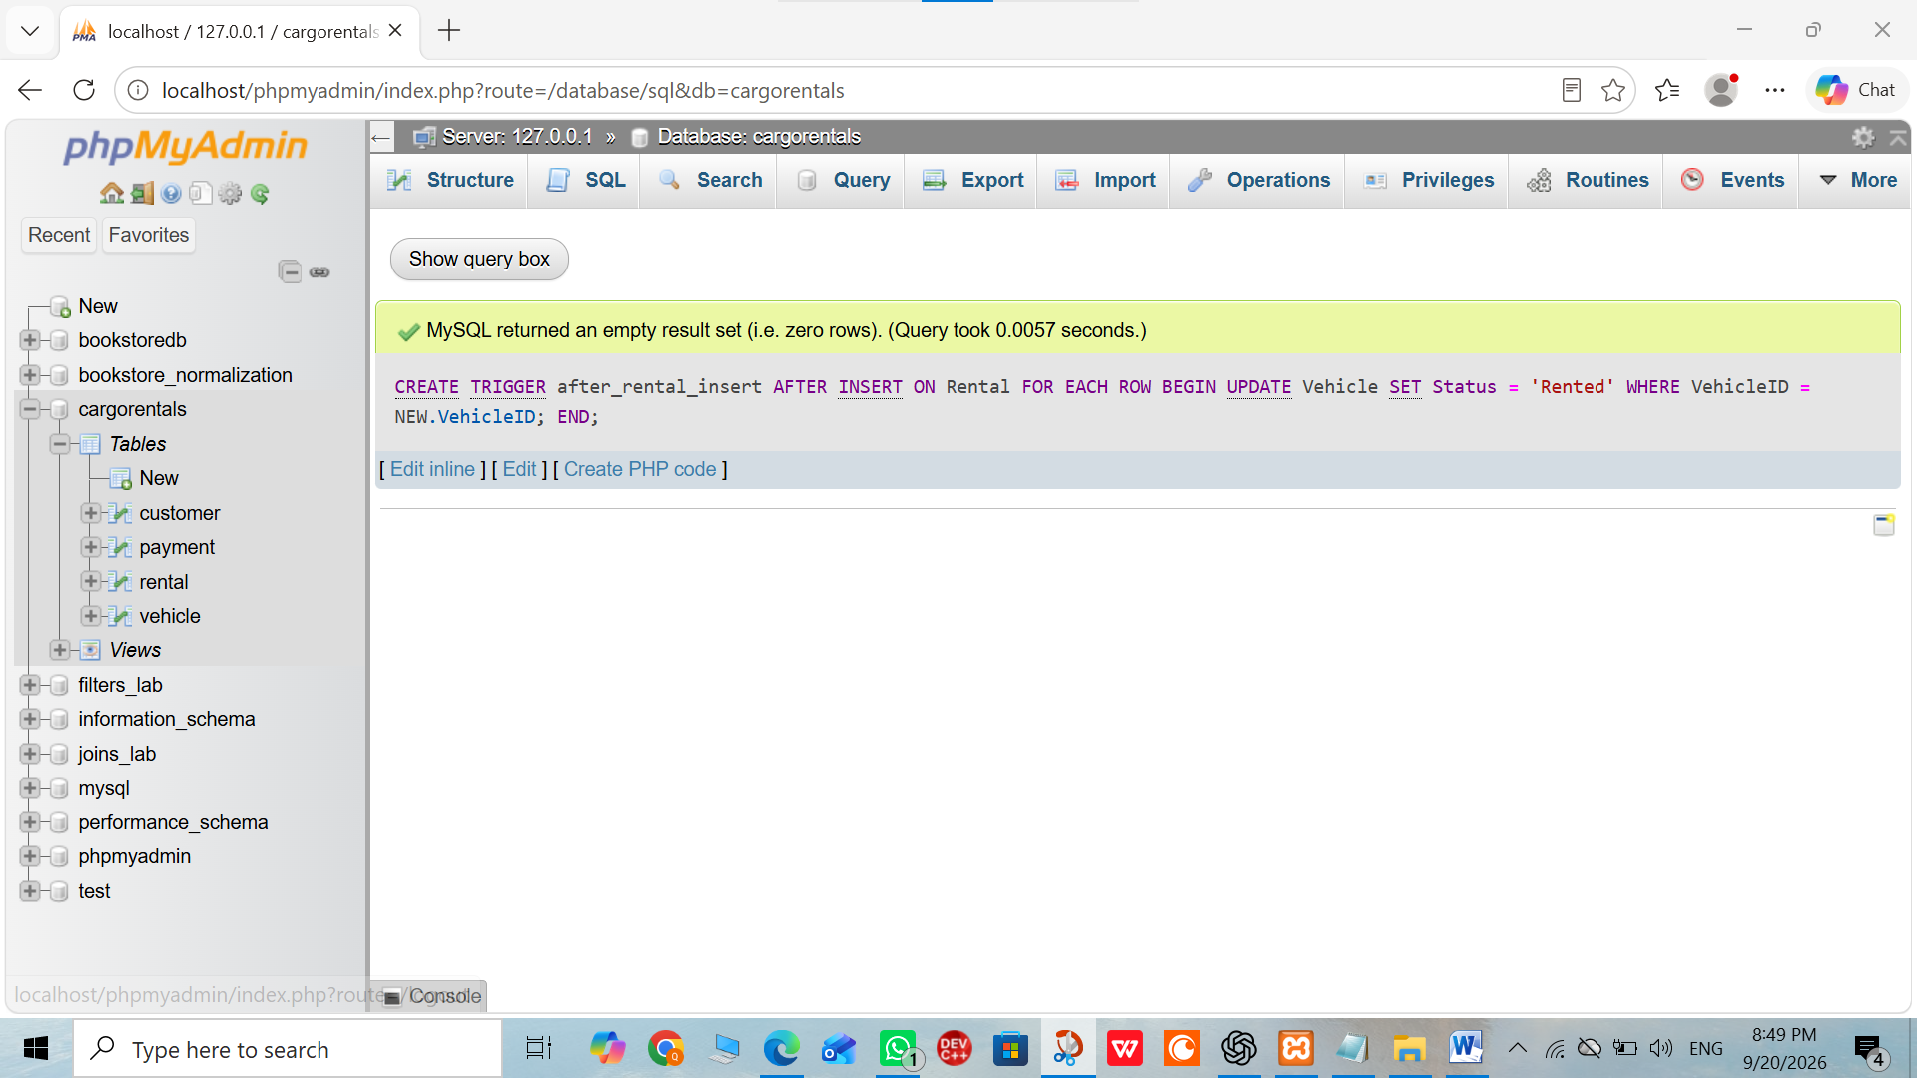
18: Vehicle Index:
Creating Index on VehicleID
An index named idx_rental_vehicle is created on the VehicleID column of the Rental table to improve query performance.
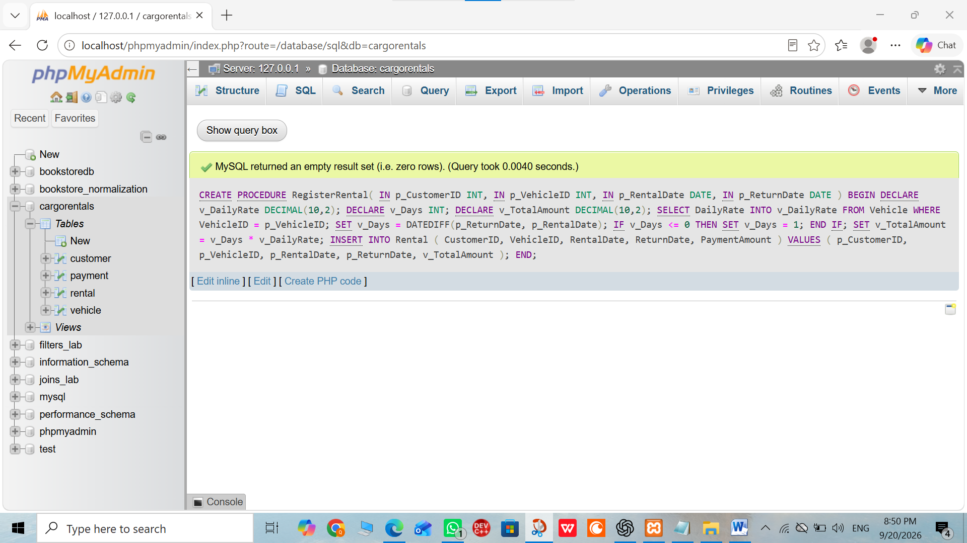
19: Payment Index:
Creating Index on RentalID
An index named idx_payment_rental is created on the RentalID column of the Payment table to improve query performance.
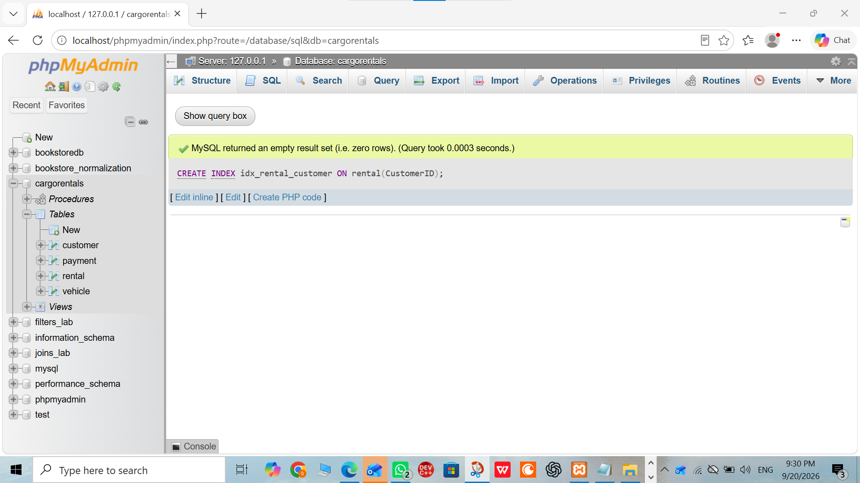
Overall order of Report:
Database & Tables → Data Insertion → JOIN/Queries → View → Trigger → Stored Procedure → Indexing/Optimization

